IGUIDE Manual

Contents

Introduction 1

Overview 2

Setting up IGUIDE 3

Hardware 3

Parts list 3

Software 3

Download 4

Prerequisites 4

Installation 4

Updates 4

Using IGUIDE 4

# Introduction

The *Image Guided User Interface Directing Eyes* (or IGUIDE for short) offers a customizable fixation target to a subject for imaging user-definable areas of the retina in a given AO(SLO) setup. The operator selects the desired spot on the retina to be imaged on a pre-defined grid or a fundus overlay view of the subject. As the subject fixates the target that is presented to him, his/her eye moves into the direction necessary to image the location of the retina the operator wants to acquire.

You can save the coordinates of the visited areas for later re-visiting, or use these coordinates for later AO(SLO) image montaging. It is also possible to use IGUIDE as a remote control for third-party software native to AO(SLO) setups like ICANDI or AOSACA for improving the overall imaging workflow.

# Overview

To give an example for easy integration, the following figure shows an IGUIDE setup in a given AOSLO environment.

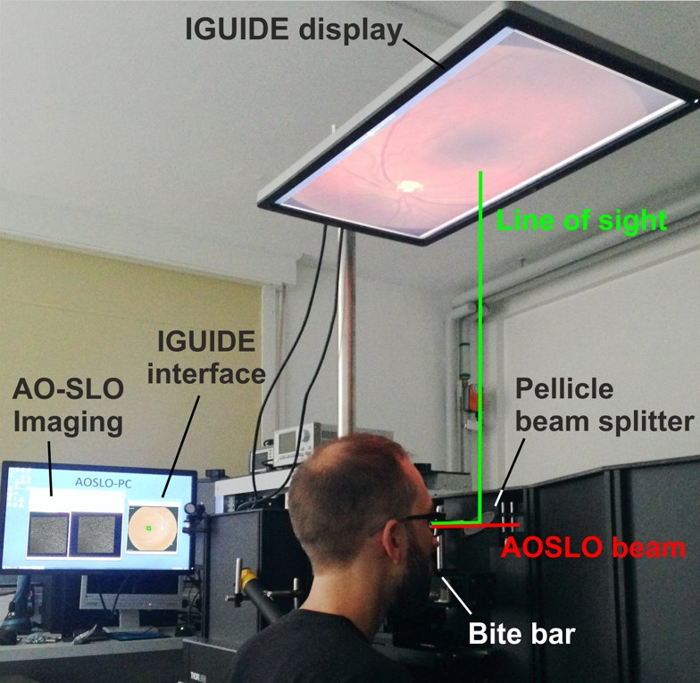

Figure 1: IGUIDE in an AOSLO environment

The IGUIDE system is comprised of a *Pellicle beam splitter*, an external Display and Software running on a PC. The beam splitter allows for superimposing the *IGUIDE display* onto the *AOSLO beam*. The subject interfaces with a bite bar to maintain position.

The *IGUIDE display* is connected to a second video output of the same PC used for AOSLO imaging, offering an extended desktop for the projection of the fixation target. The *IGUIDE interface* as shown in Figure 1 is the main application window of IGUIDE. Hence it will be referred to as “Operator View” while the *IGUIDE Display* will be referred to as “Subject View”. Other software native to the AOSLO environment is depicted as *AO-SLO Imaging* (i.e. ICANDI, AOSACA).

# Setting up IGUIDE

In this chapter you will learn what steps are necessary to integrate IGUIDE into your (AO)SLO system. It is divided into a Hardware and Software section, both mandatory for deployment. First you will learn what mounting parts are need for the assembly of the *IGUIDE Display*, the *Beam Splitter, etc.* and then we will move on to the Software Installation.

## Hardware

There are references about specific hardware matching the environment that IGUIDE has been tested and developed in. However, there are different solutions to get IGUIDE up and running in your setup, so just remember that this is just a recommendation. There is no affiliation to any of the companies mentioned providing the hardware for setting up IGUIDE. However, should you decide to use different hardware please make sure to check for compatibility in specifications first.

### Parts list

Thorlabs can provide you with the parts you need for the assembly. Basically everything you need except for the *IGUIDE display* can be ordered from them.

To fix your *IGUIDE display* to your breadboard, several components are required. Once assembled, they build a gallows frame for the display to hang from. For this you will need:

|  |  |  |
| --- | --- | --- |
| **Qty** | **Part No.** | **Description** |
| 1 | TA2 | Tabletop Post Mounting Adapter |
| 1 | PSY121 | Flat Screen Monitor Support Bracket with Articulating Arm |
| 1 | PSY162 | Ø1.5" (38 mm) x 1000 mm Post for ScienceDesk and Optical Table Frames |

For the beam splitter you need:

|  |  |  |
| --- | --- | --- |
| **Qty** | **Part No.** | **Description** |
| 1 | BP208 | Ø2" Pellicle Beam Splitter, Uncoated for 8:92 (R:T) Split Ratio for 400-2400 nm |
| 1 | BP207 | Ø2" Fixed Pellicle Mount |
| 1 |  | Beam Splitter Mounting hardware, matching your setup (i.e. posts, clamps, etc.) |

## Software

To finish your IGUIDE setup, you need to install the IGUIDE Application.

### Download

IGUIDE has been written for Microsoft® Windows™ operating systems and is compatible with all versions of Windows™ 7 and above. There are 32-bit and 64-bit versions of IGUIDE. Depending on your Windows™ system type, please select the appropriate version when downloading. You can get the latest version of IGUIDE at:

<http://ao.ukbonn.de/resources.html>

You can also find this manual in its latest edition on that website.

If you are a member of the C-RITE consortium, you will also have access to the source code of IGUIDE. Check out <https://github.com/C-RITE/> for a list of all sources.

### Prerequisites

Before you can run IGUIDE you will first need to install the Visual C++ Runtime from Microsoft®. Depending on your Windows™ system type, you must choose either the 32-bit or 64-bit runtime. You can obtain them from Microsoft on their website or follow these links directly:

<http://go.microsoft.com/fwlink/?LinkId=746571> (32-bit)

<http://go.microsoft.com/fwlink/?LinkId=746572> (64-bit)

If you are unsure about which one to take, 32-bit is a safe bet. Windows® backward compatibility allows you to choose 32-bit runtime in a 64-bit Windows® environment.

Just be sure that the chosen Visual C++ Runtime matches your download choice of IGUIDE (32-bit or 64-bit).

### Installation

IGUIDE comes as a standalone executable (.EXE) file, which you may copy to any destination folder on your computer. You can double-click the file in your (download)-folder to execute IGUIDE directly, or create a shortcut to your desktop. Just drag-and-drop the file to the desktop while pressing the ALT-key.

### Updates

You can find the latest version of IGUIDE on our website <http://ao.ukbonn.de/resources.html>. Current versions offer new features or fix issues. If you think you may have found a bug, please file a bug-report on C-RITE.

# Using IGUIDE